*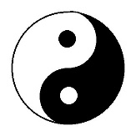TAI CHI CHUAN -* HFE 103-003 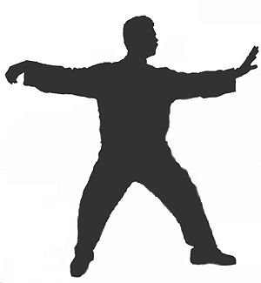

Tai = Grand or Supreme

Chi = Terminus or Polarities

Chuan =Fist

Grand Ultimate Fist or Supreme Ultimate Fist

A better translation may be: Great Polarities Martial Method

The term *Tai Chi* comes from Taoist philosophy. In Taoism, the *Tai Chi* or “Great Polarities”, refers to the relationship between the two opposite yet harmonious forces of nature known as the “*Ying*” and the ”*Yang*”. The Taoist created the Yin and Yang symbol, which is known in China as the “Tai Chi Diagram”, or the Tai Ji Tu (Taijitu). It shows how the extreme of one is the birth of its opposite and how the two are united as a whole through the Center Point. Two Polarities: each one only existing because of the other and continually begetting each other. This is the Flow in which you become one in an ever –deepening practice of *Tai Chi Chuan.*

*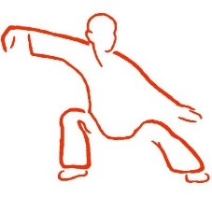 Qi Gong 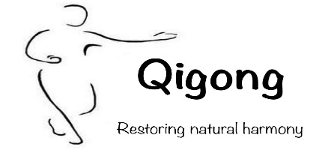*

Qi = Vital Energy

Gong = Work

*Qi Gong* = is the exercise of cultivating and protecting “*Vital Energy*”.

We need Vital Energy to be able to function or “*Dance with the Ultimate Energy of Change”.* QI Gong is an exercise for enhancing all Physiological Functions including:

Physical strength, flexibility, balance, endurance, and coordination.

1. The Four Corrections
2. PROPERLY POSITION YOUR BODY (“***Ma Bu***”)
3. BREATHE DEEP (“***Dantian***”)
4. RELAX MUSCLES (“***Song***”)
5. QUIET THE MIND (“***Jing***”)
6. Tai Chi & Qi Gong : Warm-Up
7. Bear Dance
8. Swirl cup of tea
9. Sway body like a dragon
10. Wave Hands like clouds
11. Repulse the monkey
12. Part horse’s mane
13. Empty step pivot
14. Empty step pivot kick
15. Brush the floor
16. One leg squat
17. Heel slides
18. Circles in the sand
19. Internal (Nei) Qi Gong
20. Gather Lung Qi (flexion)
21. Protect Heart Qi (scaption)
22. Calm Liver Qi (Abd, ER, IR)
23. Strengthen Kidney Qi (Er, IR)
24. External (Wei) Qi Gong
25. Eagle loosens its wings
26. Monkey wraps arms around the tree
27. Bear swimming through the water
28. Deer turns to face the moon
29. Snake coils and uncoils

5. The Bamboo Sequence

1. Reach Up to the sunlight 5. Push back the knees

2. Bend Forward and Back 6. Twist to the left and right

3. Bend from side to side

4. Fold like a silk scarf